1. **Agenda**: We can filter an array or collection which appears inside the **Variables or Watches** Sections.
2. Let’s filter array “numberArray” of size 10,000.
3. 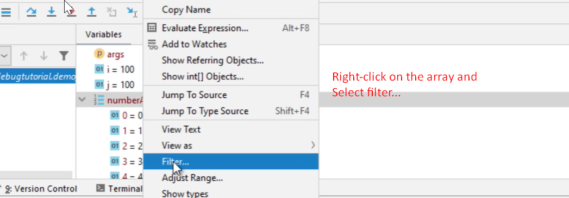
4. 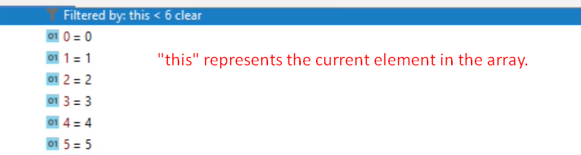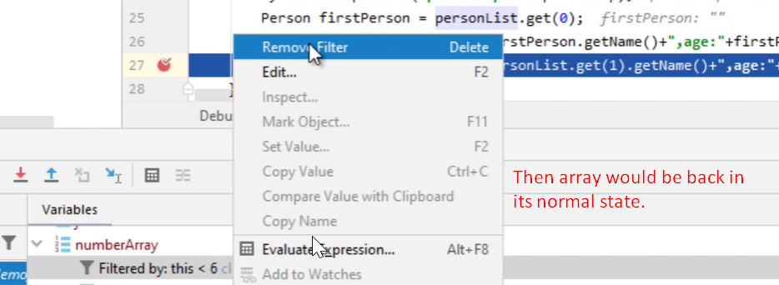
5. 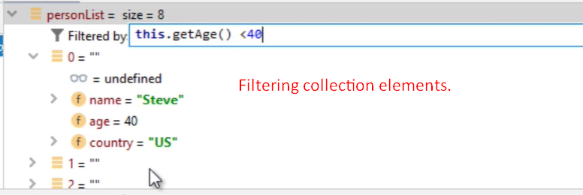
6. 